LOCATION : NATIONWIDE
DATE : 10.11.2017
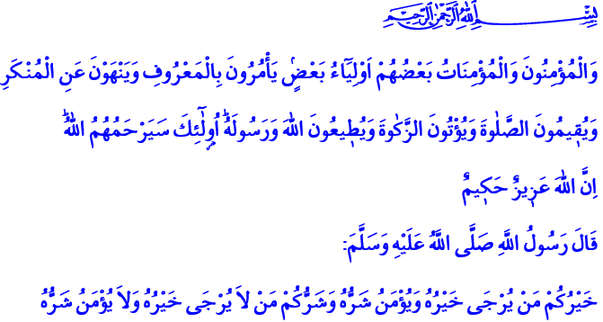
BELIEVER, THE ROLE MODEL
Blessed Friday to You All, Brothers and Sisters!
Our Lord Almighty enjoins in the verse I have recited: “The Believers, men and women, are protectors, one of another: they enjoin what is just, and forbid what is evil: they observe regular prayers, practice regular charity, and obey Allah and His Messenger. On them will Allah pour His Mercy: for Allah is Exalted in power, Wise.”
One day, our Prophet (pbuh) asked his companions: “Shall I not inform you of the best of you from your worst?” and continued: “The best of you is the one whose goodness is hoped for, and people are safe from his evil. And the worst of you is he whose goodness is not hoped for, and people are not safe from his evil.”
Dear Brothers and Sisters!
Our Prophet (pbuh) showed us how to be a good believer, a role model through his words and his life. Let us pay heed to the characteristics of an exemplary believer in this khutba, as told and lived by our Prophet, Muhammad the Trustworthy. Let us remember again the good things that will bring us peace and happiness in this world and eternal salvation in the Hereafter.
In the words of Allah’s Messenger (pbuh), a believer is submissive and loyal above all. He is precious, just like gold. Throughout his life, he displays an Abrahamic stance and keeps his dignity. He would stand on his values and faith in every situation and says: 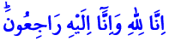, meaning: ‘To Allah we belong, and to Him is our return’. He would not abandon the guidance of the Quran and the noble Sunnah, and would not turn away from the straight path.
In the words of the Great Messenger (pbuh), a believer is like a honey bee. Just like a honey bee, he would only eat nice, clean, halal things and produce good things. He would not hurt or harm anybody. His heart only has place for the good, the useful and the positive; but not for the bad, the harmful and the negative.
Dear Believers!
A believer is like a date tree, as in our Prophet’s expression. He would keep his strength, his vitality through the power from his faith. He would be beneficial to humanity without forgetting his purpose of creation.
A believer would not fall down but stand firm, even if he was tested with all kinds of misfortunes. He knows that a believer’s task is to accept the tests and misfortunes with patience, steadiness and solemnity just like Ayyub did. It is to be able to say “Your grace is welcome, Your wrath is too” to whatever’s coming from Allah Almighty.
Honorable Believers!
There is no place for sadness and despair in the life of a believer. He believes in this verse with all his heart: 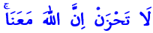 “Have no fear, for Allah is with us”. He knows that he has a protector who stands by his side when there are none, and who provides hope and relief.
A believer is a person whose tongue and hands people are safe from. He would take refuge in Allah from deceiving and being deceived, in accordance with this hadith:  meaning: “Those who deceive is not one of us.” Bad and false words, insulting and heartbreaking expressions would not come out of a believers mouth. He would not marginalize, but he would unite; he would not hate, but he would be the bringer of glad tidings. He knows that one day he will account for all his actions and all his words.
Honorable Brothers and Sisters!
A believer has sagacity, discernment and moderation in the words of our Prophet (pbuh). He considers life and events as lessons and wisdom. “A believer is not stung twice (by something) out of one and the same hole” He would not knowingly fall into error. He would not allow his faith, feelings and thoughts to be exploited. He would not give his heart and mind to others.
A believer is humble, as he knows this hadith: “He who has in his heart the weight of a mustard seed of pride shall not enter Paradise.” He loves the Created for the Creator’s sake. He would know that a person is no good if he does not befriend others and others could not befriend him. His actions are dressed in mercy, compassion, sincerity, friendliness and fondness.
And finally, a believer is like herbalist who sells nice perfumes. He would offer people ethics, morals and virtue. He would take a good place in the minds of the people. He would always leave a nice voice in the hearts.
Brothers and Sisters!
How happy are those who is honored by these praises of our Prophet (pbuh)! How happy are those who obtained the countenance of Almighty Allah by embracing the reason of creation! How happy are those who transformed the mortal world into eternal treasure!

At-Tawbah, 9/71.
At Tirmidhi, Al Fitan, 76; Ahmed b. Hanbel, II, 268.
Ahmed b. Hanbel, II, 199.
Ahmed b. Hanbel, II, 199.
Al Bukhari, Good Manners and Form (Al-Adab), 89.
Al Bukhari, Onenness, Uniquness of Allah (Tawheed), 31.
At-Tawbah, 9/40.
Al Bukhari, Faith, 4.
Sahih Muslim, Faith, 164.
Al Bukhari, Good Manners and Form (Al-Adab), 83.
Sahih Muslim, Faith, 147.
Ahmed b. Hanbel, II, 400.
Taberânî, el-Mu’cemü’l-Kebir, XII, 319. Written by: General Directorate Of Religious Services

